LE can be present long before there are any visible or measurable changes noted. Early stage 0 LE may appear only as a sense of heaviness or achyness in the limb without any visible signs of swelling. There are still tissue changes occurring in the interstitial spaces of the limb, however, that could be detected by specialized tools such as perometry or Bio Impedence units. This is why it is so important for women at risk for LE to be aware of these early warning signs and get evaluation as soon as possible by a certified LE therapist. Please do not wait for swelling to be visible before being evaluated if you are already having concerns with discomfort, a sense of heaviness, fullness or aching.
Once we have visible signs of swelling it may be easier to convince the physicians and other medical professionals that we have LE but even then our unique symptoms may be attributed to other potential medical conditions. There is something in the medical field called "differential diagnosis" which just means they look at all the possible causes for your presenting symptoms and using the process of elimination try to narrow down the actual cause. That is why when presenting for the first time with swelling the doctor may want to rule out other causes of oedema like infection, blood clots, vascular insufficiency, congestive heart failure, adverse response to medications etc. Getting the correct diagnosis is important so we should not just "assume" we have LE when presenting with symptoms of pain and swelling. Our ability to describe and point out the visual clues of our symptoms, however, will greatly help the physician in coming to the correct diagnosis.
One other point I want to stress is that everyone’s LE is unique in its presentation. My LE will not be exactly like your LE. We may share many common aspects though, so I feel it can be helpful to show visual images of LE. I post these images purely for informational/educational reasons and just as an EXAMPLE of how LE may present. I wanted to emphasize the comparisons between a LE and NON-LE limb to make you all aware of some of the more subtle changes you should keep an eye out for when trying to detect your own LE.
As a quick personal history note, I have had LE for 4 years in my left arm and hand with minimal truncal LE. My right arm is at risk for LE but has not yet shown visible signs. My LE is considered Stage 2 because it does not revert to normal with elevation or garments. I have never had large volume differences between my arms. I do have a fair amount of fibrosis and swelling primarily in my hand which results in diminished strength, flexibility and fine motor skills. 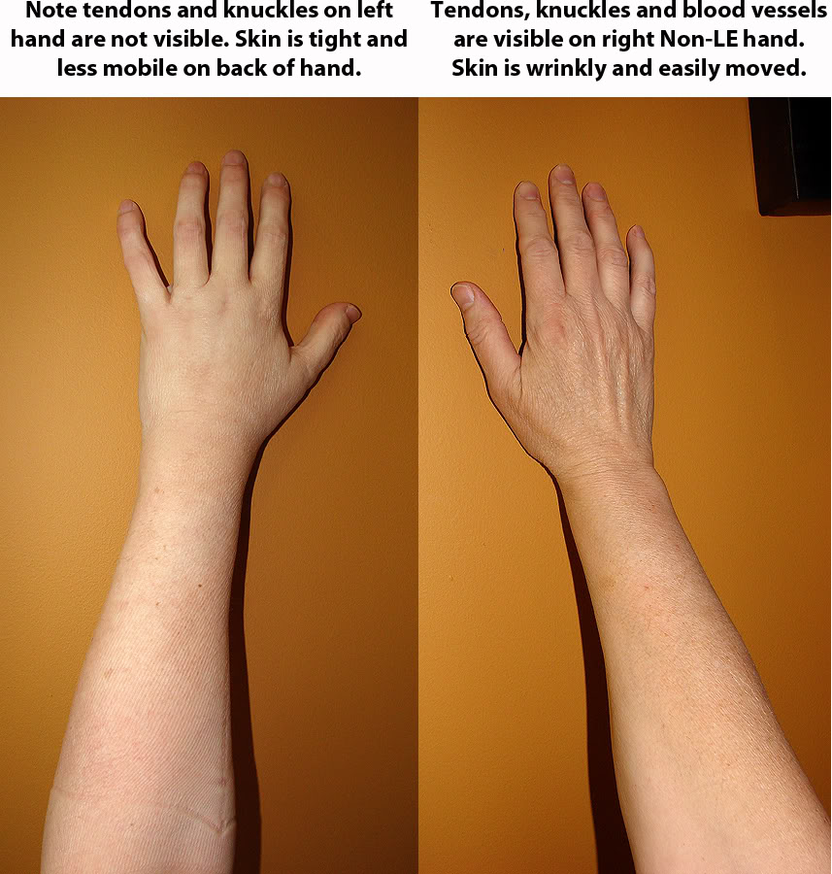
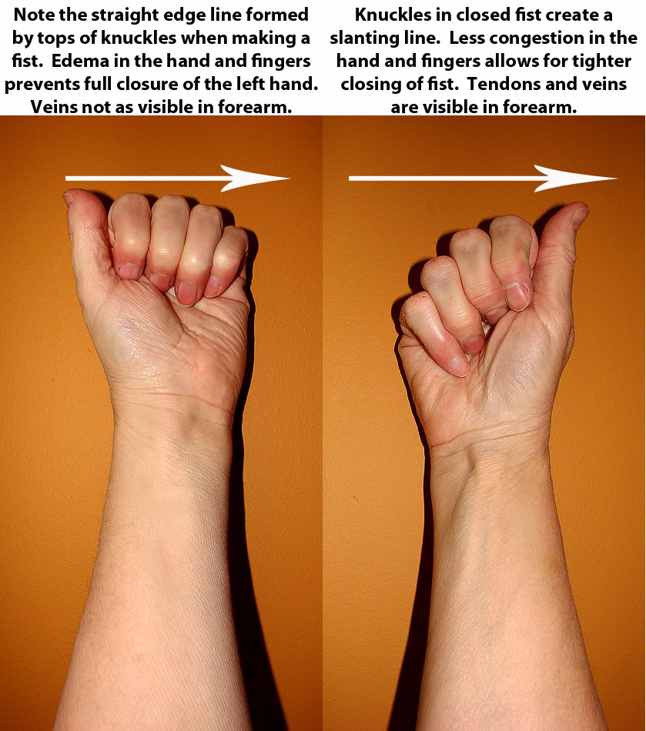
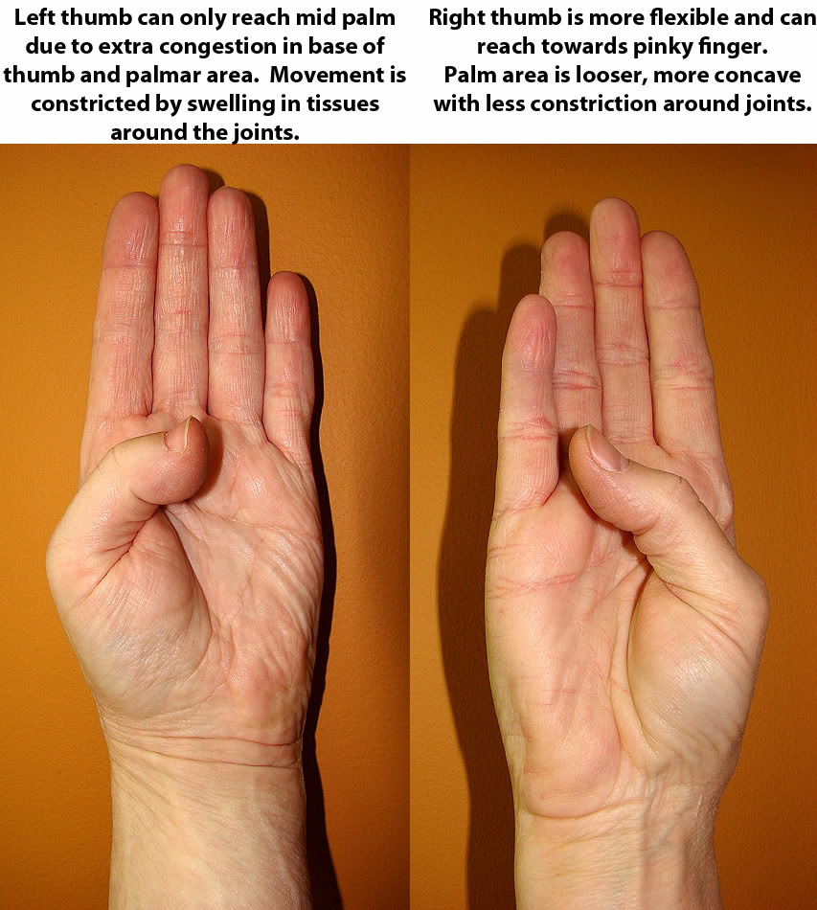
Another test of flexibility of the hand joints is to try to touch your thumb to your pinky finger and make the Boy scout sign. Remember that if you already have joint stiffness due to arthritis or medications you may not be able to do this. Typically in LE there will be a noticeable difference in range of motion between the LE and Non-LE hand.
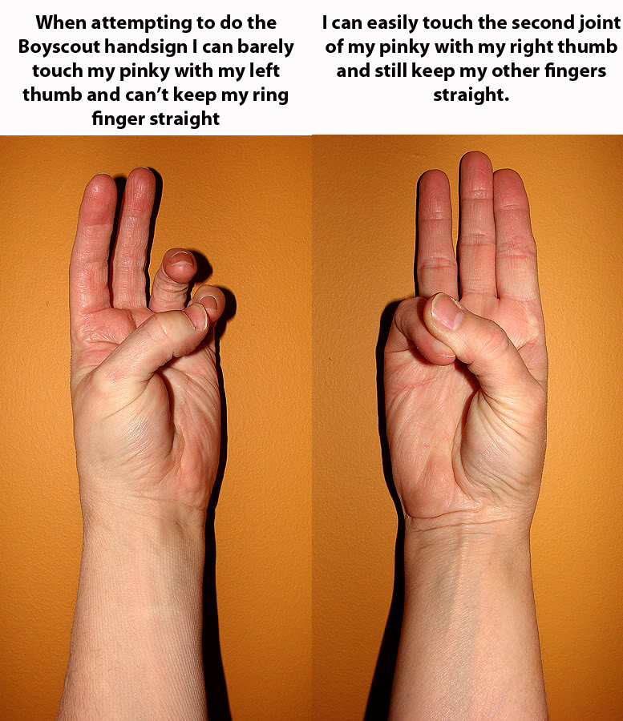
Another subtle sign of hand LE is to check the side profile of your hands. Compare the thickness from the back of the hand (Dorsum) to the palm. Try pinching the skin in the webspace between your thumb and index finger and compare thickness.
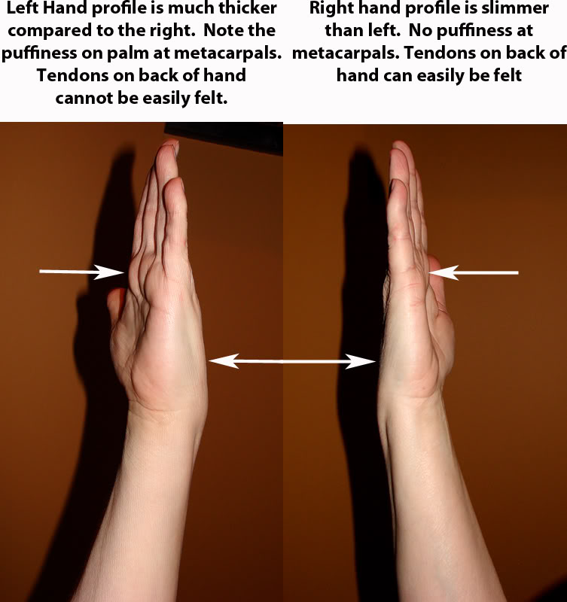
Bony prominences may not be as easily seen or felt when LE swelling is present. Check your elbows by feeling all around the bony margins when your arm is flexed to see if the edges are well defined or do they seem soft or puffy. Compare your upper arms for more fullness on the LE side or less muscle definition.
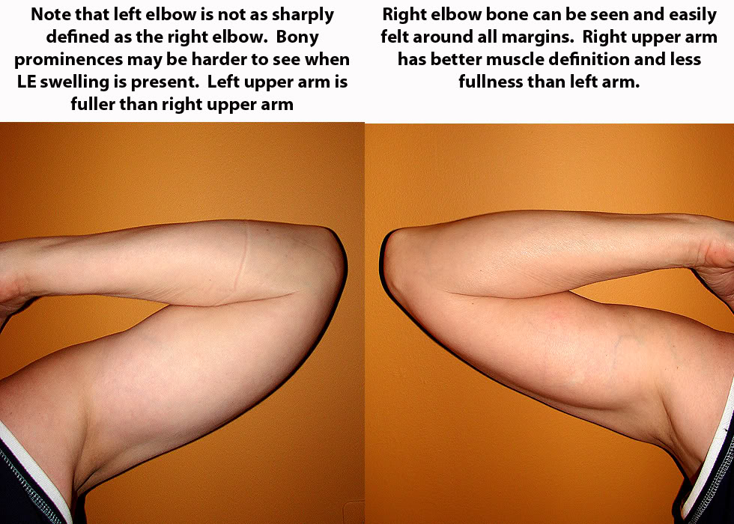

Here is an example of Pitting Edema.
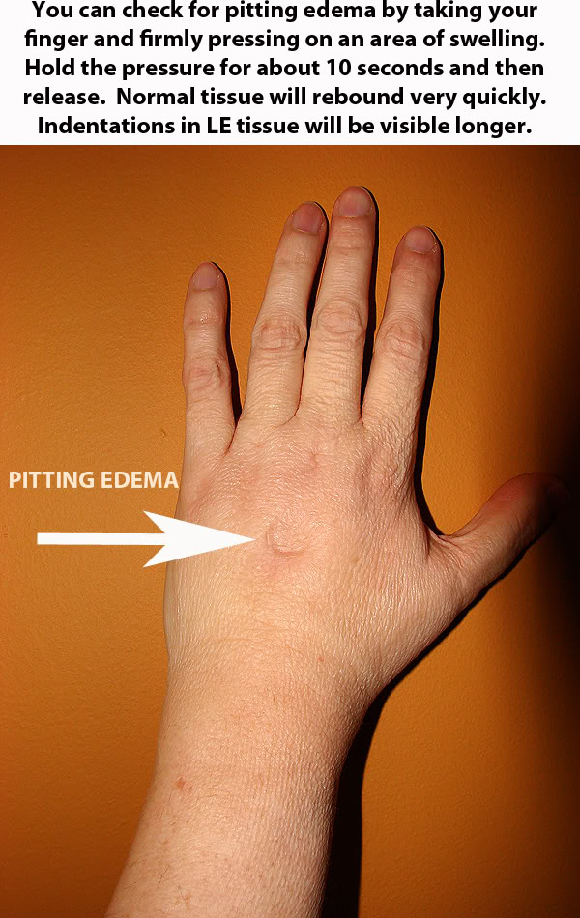
This final photo is a comparison of my left hand in 2006 to my left hand today in 2010. There have been improvements in reduction of swelling in the fingers particularly at the base of the fingers. The dorsum and palm are still congested, but there has been gradual reduction in size and fibrosis, along with improved flexibility and more mobile skin across the knuckles. In 2006 I was not able to touch my thumb to the tip of my middle finger. Today I can just touch my thumb to the tip of my pinky.
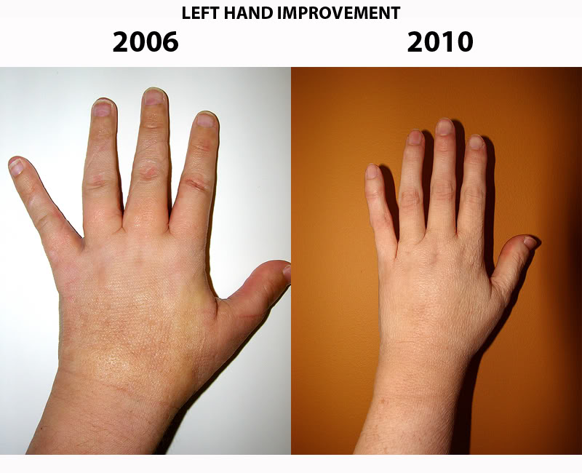
I hope these images have been helpful and can point out areas to check for early signs of LE swelling. Remember that some women have LE of the arm but not the hand, or LE of the breast/truncal area only. Everyone is different. Learn what is a change for your own body, pay close attention to the characteristics and location of any swelling. Be able to point out these subtle changes to your doctor or therapist so they can determine the best treatment for you.

